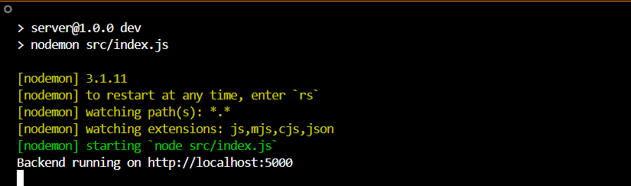
- Description:
checking if backend server is running correctly by visiting the /api/health endpoint in browser.
- What it shows:
The browser displays the response: {"ok": true}.
This means your server is active and responding to health checks, which is a standard way to confirm that the backend API is up and running.
Output:
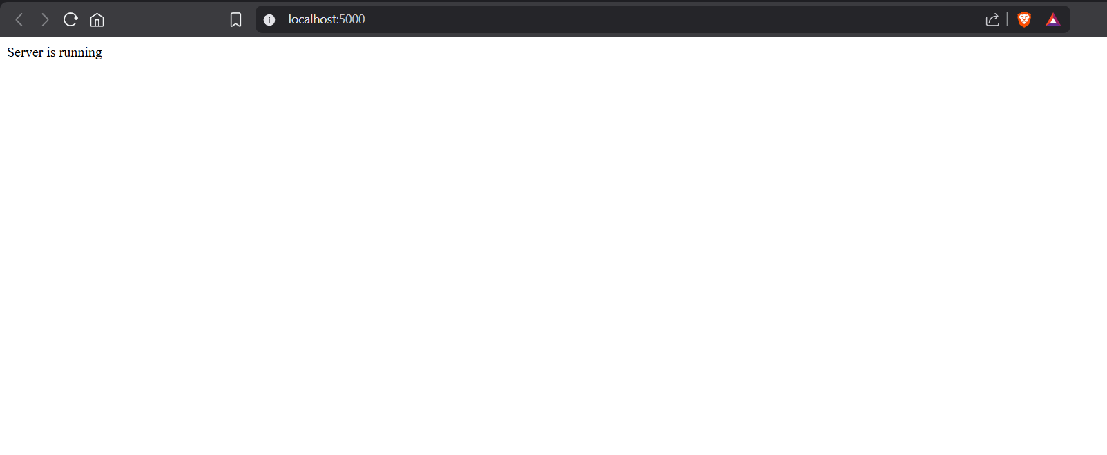

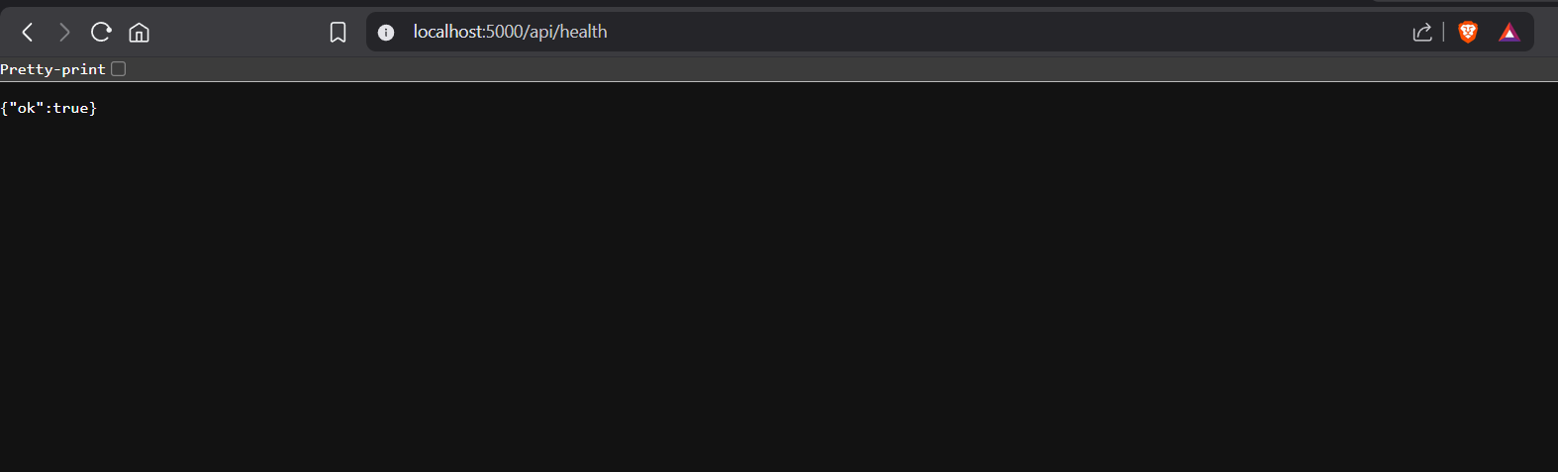
- Description:
In this image, you are checking if your backend server is running correctly by visiting the /api/health endpoint in your browser.
- What it shows:
The browser displays the response: {"ok": true}.
This means your server is active and responding to health checks, which is a standard way to confirm that the backend API is up and running.

